
NORTHERN EDUCATION DIVISION
2023 MSCE MOCK EXAMINATION
BIOLOGY
Wednesday, 15 March Subject Number: M022/II
Time Allowed: 1$\frac{1}{2}$ hour sessions
1:00 pm onwards
PAPER II
(40 marks)
Practical

Instructions
Question Number | Tick if answered | Do not write in these columns
1
2
3
4
- This paper contains 5 printed pages. Please check.

- Write your Name at the top of each page of the question paper.

- This paper contains sections A and B. Section A has two descriptive questions and Section B has two questions on experiment

- Answer all the four questions in the spaces provided in the question paper. The maximum number of marks for each answer is indicated against each question. A pencil should be used for all drawings.

- In the table provided on this page, tick against the number of question you have answered.

- At the end of the examination, hand in
your question paper to the invigilator
when time is called to stop writing.

© 2023 NED Turn over/…
Section A (20 marks)
- Describe an experiment that could be carried out to investigate types of pigments in plant leaves. Your essay should include procedure, expected results and conclusion.
________________________________________________________________________________________________________________________________________________________________________________________________________________________________________________________________________________________________________________________________________________________________________________________________________________________________________________________________________________________________________________________________________________________________________________________________________________________________________________________________________________________________________________________________________________________________________________________________________________________________________________________________________________________________________________________________________________________________________________________________________________________________________________________________________________________________________________________________________________________________________________________________________________________________________________________________________________________________________________________________________________________________________________________________________________________________________________________________________________________________________________________________________________________________________________________________________________________________________________________________________________________________________________________________
(10 marks)
Continued/…
- Describe an experiment that could be carried out to show that heat is produced during respiration. Your essay should include procedure, expected results and conclusion.
_______________________________________________________________________________________________________________________________________________________________________________________________________________________________________________________________________________________________________________________________________________________________________________________________________________________________________________________________________________________________________________________________________________________________________________________________________________________________________________________________________________________________________________________________________________________________________________________________________________________________________________________________________________________________________________________________________________________________________________________________________________________________________________________________________________________________________________________________________________________________________________________________________________________________________________________________________________________________________________________________________________________________________________________________________________________________________________________________________________________________________________________________________________________________________________________________________________________________________________________________________________________________________________
(10 marks)
Continued/…
Section B (20 marks)
- You are provided with specimen A.
- Measure the length of the specimen in mm and record it.
_____________________________________________________________
(1 mark)
- Draw the specimen and label any two parts.

(3 marks)

- Calculate the magnification of your drawing.

(3 marks)
- Explain any one observable adaptations of the specimen to locomotion.
______________________________________________________________________________________________________________________
(2 marks)
- Name the food substance found in specimen A.
___________________________________________________________
(1 mark)
Continued/…
- You are provided with 15 groundnut seeds.
- Measure the length of each seed and record the results in mm in table 1 provided. Indicate the number of seeds under each length.
Table 1
Length(mm) | 10 | 11 | 12 | 13 | 14
Number of groundnuts
(2 marks)
- On the graph paper provided, plot a graph of number of groundnuts against length.

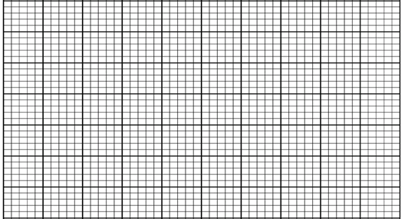

(4 marks)
- Mention the type of variation shown by the graph.
_____________________________________________________________
(1 mark)
- Calculate the mean length of the groundnuts. Show your working.

(3 marks)
END OF QUESTION PAPER
NB: This paper contains 5 pages.

